Request for Quotation to Pressure test, chlorinate and sample water pipe.

Thank you for your request for a quotation to pressure test, chlorinate and sample your external water pipe work. For us to prepare the quote, we require that you complete the following information.

Contact Details

Name:

Contact phone number:

Company (if applicable):

Site Address:

Pipe Details

Please complete the details of each pipe to be tested in the table below. Each individual pipe will need to be entered so please extend the table if necessary. It is important this information is entered correctly to enable Pipeline Solutions to provide you with an accurate quote.

Water Source

In order to carry out the pressure test and chlorination we require a potable water source. If this is a metered supply the bill payer’s authority must be obtained before we can use it on your behalf. If there is no useable potable water source on site, you, the customer will need to arrange this with your local water company.

Pressure Testing

The new pipe work will be pressure tested to ensure it is watertight and a certificate issued to that effect. If the new pipe work does not pass the pressure test, then sampling will not be carried out. The site contact will be notified of the failure and no further work will be completed until the leak has been rectified. This will incur extra costs due to extra site visits/works.

Sampling

Samples will be taken and analysed at one of our UKAS accredited laboratories. In the event that the water samples fail the testing procedure your pipe work will need to be re-chlorinated and resampled. The cost to carry out any the above will be set out in our quote. A certificate will be issued following analysis and outcome of the sample/samples.

Pipe Detail

Add one entry for each pipe that requires testing. Please refer to Table Guidance notes on the next page if required.

Pipe | Material | Diameter | Length | Number of Sample Ends | Test Ends Fitted: Y/N
1
2
3
4
5
6
7
8

- Is there a potable water source on site which can be used for this work Yes/No?
i.e. (existing live supply / available hydrant)

- How far is the access to water source from site (in metres)?

- Additional Services

Should you require us to install your private pipework please tick the box

I confirm that the information provided is correct and accept that this forms the basis of the required quotation.

Customer Signature:

Please return by email to: tws-ops@nwl.co.uk

Table Guidance

- Pipe Material:
Please state whether PE (MDPE), Barrier Pipe, or Metallic. Please note, we cannot carry out the pressure testing of Acrylonitrile Butadiene Styrene (ABS) or Glass Reinforced Plastic (GRP) pipe work.

- Pipe Diameter:
For MDPE / HDPE / Barrier Pipe this is measured as the outside diameter (OD) expressed in millimetres, for example 32mm, 63mm. For metallic pipe work this is usually expressed as the internal diameter (ID) in inches or millimetres.

- Length of Pipe Run:
The total length of pipe to be tested, measured from the boundary to the point it terminates within the premises. Please include any tee off’s, we must know the full length of pipe work to be tested.

- Pipe Ends to be Sampled:
Each pipe end at the premises needs to be sampled. If the pipe terminates at one point in the premises without any tees the answer to this is 1. If there are tees off of the pipe run each tee end must be tested and sampled.

- Test Ends:
To comply with Water Regulations the pipe in question will have been fitted with either a test end or a cap end (please see examples below). Test ends can usually be identified as isolation valves with a pipe connection facility. If test ends have been fitted please mark as ‘Y’. If not, or you are not sure, please mark as ‘N’ and we will allow for their installation if necessary.

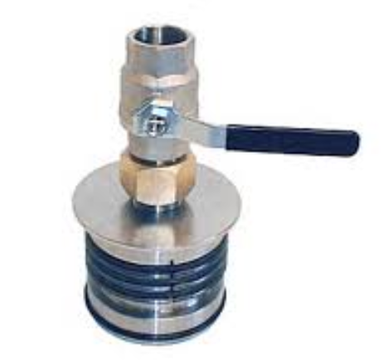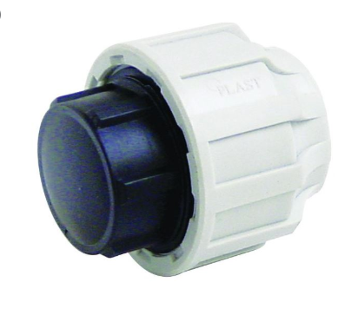

Example of a Test End Example of a Cap End

